Student Name: Rakyan Satrya Adhikara

Student ID: 219548135

Practical Task 1.3 (Helping Your Peers)

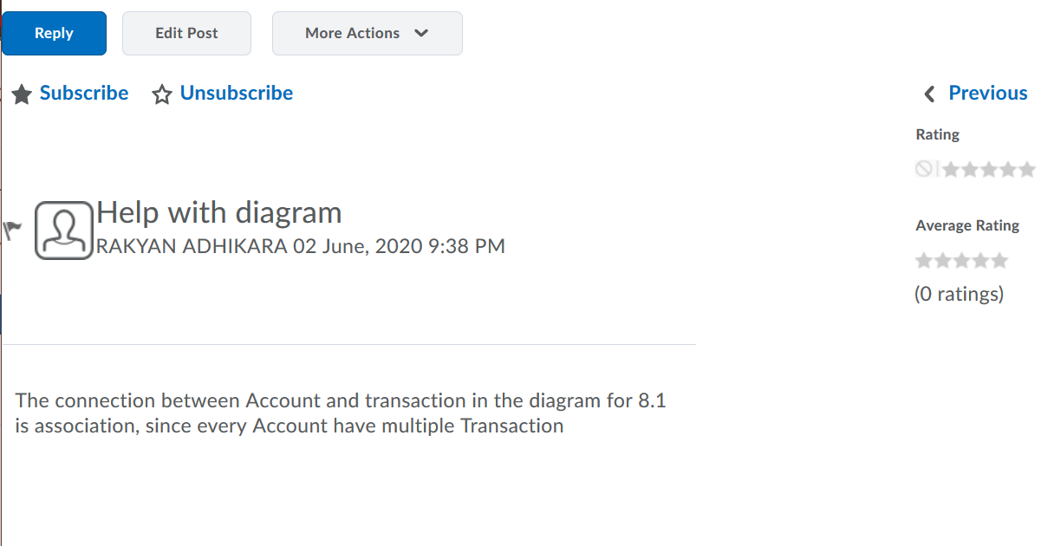

I have learned more about connections on every class, such as association, which is between the Account class and Transaction Abstract Class